Problem 12
Using the output shown in Figure P7.12 as your guide, generate a list of customer purchases, including the subtotals for each of the invoice line numbers. The subtotal is a derived attribute calculated by multiplying LINE_UNITS by LINE_PRICE. Sort the output by customer code, invoice number, and product description. Be certain to use the column aliases as shown in the figure.
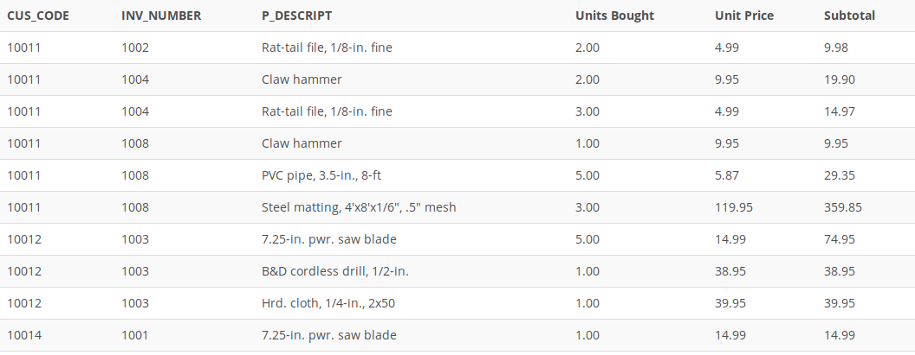

Problem 13
Write a query to display the customer code, balance, and total purchases for each customer. Total purchase is calculated by summing the line subtotals (as calculated in Problem 12) for each customer. Sort the results by customer code, and use aliases as shown in Figure P7.13.
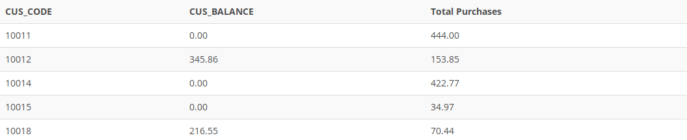

Problem 14
Modify the query in Problem 13 to include the number of individual product purchases made by each customer. (In other words, if the customer’s invoice is based on three products, one per LINE_NUMBER, you count three product purchases. Note that in the original invoice data, customer 10011 generated three invoices, which contained a total of six lines, each representing a product purchase.) Your output values must match those shown in Figure P7.14, sorted by customer code.
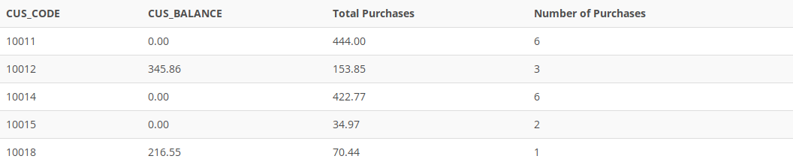

Problem 15
Use a query to compute the total of all purchases, the number of purchases, and the average purchase amount made by each customer. Your output values must match those shown in Figure P7.15. Sort the results by customer code.
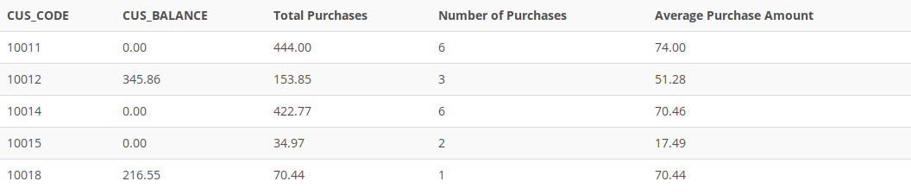

Problem 16
Create a query to produce the total purchase per invoice, generating the results shown in Figure P7.16, sorted by invoice number. The invoice total is the sum of the product purchases in the LINE that corresponds to the INVOICE.
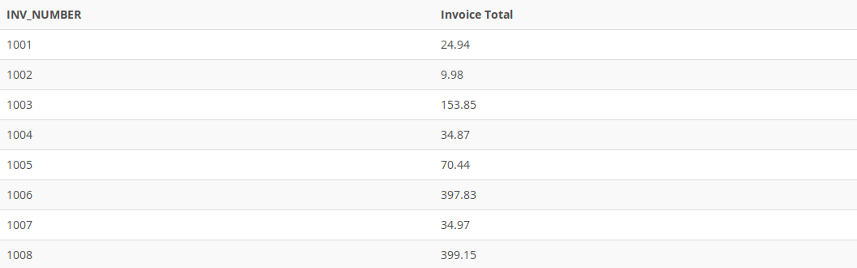

Problem 17
Use a query to show the invoices and invoice totals in Figure P7.17. Sort the results by customer code and then by invoice number.
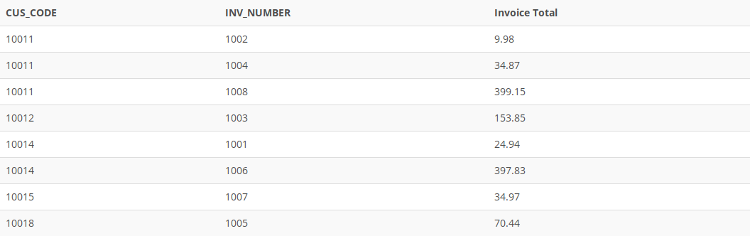

Problem 18
Write a query to produce the number of invoices and the total purchase amounts by customer, using the output shown in Figure P7.18 as your guide. Note the results are sorted by customer code. (Compare this summary to the results shown in Problem 17.)
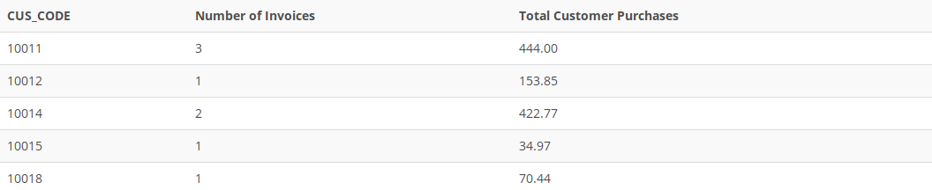

Problem 19
Write a query to generate the total number of invoices, the invoice total for all of the invoices, the smallest of the customer purchase amounts, the largest of the customer purchase amounts, and the average of all the customer purchase amounts. Your output must match Figure P7.19.

Problem 20
List the balances of customers who have made purchases during the current invoice cycle—that is, for the customers who appear in the INVOICE table. Sort the results by customer code, as shown in Figure P7.20.
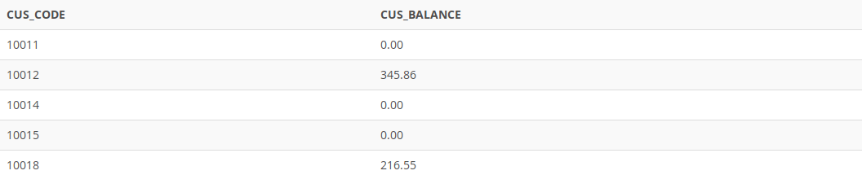
Provide a summary of customer balance characteristics for customers who made purchases. Include the minimum balance, maximum balance, and average balance, as shown in Figure P7.21.

